УРОК АНГЛИЙСКОГО ЯЗЫКА ПО ТЕМЕ "ПРОБЛЕМЫ МОЛОДЕЖИ"
Вид урока: повторительно-обобщающий
Цель: Обсудить актуальные проблемы подростков в современном обществе и найти пути их решения.
Задачи:
1. Обобщение знаний учащихся по данной теме с употреблением изученной лексики.
2. Совершенствование навыков устной речи.
3. Развитие творческих способностей и воспитание интереса к изучению английского языка,
Ход урока:
Организационный момент (обчающиеся садятся на свои места, проверка готовности к уроку)
Приветствие учащихся.
Good morning, students! I am glad to see you. How are you? OK, let’s start our lesson.
Знакомство с темой и планом урока (Сообщение целей и задач)

Today we shall speak about you, it means about teenagers. Our theme is “Teenagers and their problems.
Today you will:-Listen, read and talk about yourself, teenager’s problems, teenager life and interests.(цель и задачи представлены на слайде) And we should answer the question. It is easy to be a teenager?”
So, pupils, who are teenagers?
Фонетическая зарядка: хоровое чтение слов Students, now we remember the qualities of teenagers, repeat after me
aggressive – агрессивный
nervous – нервный,
Impatient – нетерпеливый
rude – грубый
secretive – скрытный
selfish – эгоистичный
violent – вспыльчивый
hard-working – трудолюбивый
Imaginative – творческий
sociable – коммуникабельный
creative - среативный
brave - храбрый
shy - застенчивый
honest -честный
Lazy- ленивый
What qualities are positive, negative?
Речевая зарядка
Праверка Д/З now we check homework
What do the eldest think about teenagers today?
- According to “the older generation” teenagers are lazy.
- They wear ridiculous clothes and are rude to their betters and elders.
- Teenagers find it impossible to be polite, helpful, constructive, hard-working.
- They spend all their time listening awful music and watch bad films.
- They think only about parties.
What opinions have elders, positive or negative?
Why elders have negative opinions about teenagers?
Youth is a very important period in the life of a person, but young people face a lot of problems. They can meet difficulties everywhere: at home, at school, in the street.
Read and translate
- Problems at home with parents /My parents don’t understand me.
- Problems at college with teachers.
- Problems with classmates
- I have too much homework.
- Misunderstanding with… parents/frends/teachers
- smoking
- using drugs
- using alcohol drinks
- getting and spending money
- The first love.
- Problems with friends.
- Harmful habits.
Everybody of you is a teenager. What problems do you have in your daily life?
Основная часть
3 человека подготавливают диалог. Остальные выполняют задания: читают тексты и соотносят их с заголовками.
Диалог
- Mother: Children, I want to spend a weekend together with all the family
- Son 1: Mammy, But I want to go for a walk with my friends
- Son 2: And I want to stay home and play computer games
- Mother: Children, I work hard and have a little time for you, I want to spend weekend together.
- Son 1: I dont want
- Son 2: And I
- Mother: Haw can we solve this problem?
- Son 1 Son 2: We stay at home!!!!
- Mother: No, I have an idea, we go to the picnic and you can invite all your friends, and we will play different games and you can take notbook.
- Son 1:Good idea
- Son 2: It is so wonderful to spend time in the open air
- Son 1: I love you Mammy
- Mother: I love you my children

Read the texts and choose the titles (5-7 мин)
Обратите внимания, какие 2 заголовка похожи. Перевод.
Вам необходимо к каждому тексту подобрать заголовок, и найти в тексте подтверждение, что именно этот заголовок верный.
1. Do Teenagers Have Problems?
2. Typical American Teenagers.
3. Are Teenagers a Problem?
4. What is a Teenager?
A. Officially, a teenager is anyone aged from 13 to 19 inclusively, but most people would probably think first of the younger age group and exclude 18 and 19-year-olds. After all, once you reach 18 you can vote, get married without your parents’ permission, and join the army. On the other hand, children are growing up and developing more quickly, and these days 11 and 12-year-olds would like to include themselves in the ‘teenager’ group.
B. According to ‘the older generation’, teenagers are lazy, they wear ridiculous clothes, and are appallingly rude to their betters and elders; they find it impossible to be polite, helpful, constructive, caring or hard-working. What’s more, they spend all their time listening to awful music and watching unsuitable films.
C. Teenagers are human so, of course, they have problems. It is a difficult time for them because it is a period of transformation. It isn’t quite as bad as a chrysalis changing into a butterfly, but it may seem like that. It isn’t easy to grow up, and the dramatic physical and emotional changes are often confusing and worrying.
D. Typical American teenagers are in fact very ordinary. They think their teachers make them work too hard; they love their parents, but are sure they don’t understand anything; and their friendships are the most important things in their lives. Some of them do have a lot of money to spend, but usually they have earned it themselves.
1. – С; 2. - D; 3.- B;4.-A
После проверки задания студенты разыгрывают подготовленный диалог

So, teenagers have a lot of problems. What problems are the most dangerous? (Alcoholism, Drugs)
(Видео или презентация –алкоголизм, курение, наркомания)
Все люди прекрасно знают какой вред наносит курение, употребление алкоголя, наркотиков. Когда молодые люди начинают это употреблять они не думают о своем здоровье и о серьезных проблемах в будущем

Is it an actual question in our college?
Do pupils in our college drink alcohol?
Why do they smoke?
If anybody use drugs?
What should we do to avoid these problems?
Now we discuss advantages and disadvantages of being a teenager(двум группам раздаются листики с плюсами и минусами- одна команда отбирает плюсы, другая минусы )

Now it is time to answer our question. Is it easy to be young?
It is easy to be young, because….
It isn’t easy to be young, because….
Заключительная часть
Our lesson is over. Today we have spoken about teenagers, their problems .So, all ages have their advantages and disadvantages. We should try to be happy all time (if it’s possible).
You worked today very hard and got good mark ….
(Студенты оценивают свою работу на уроке) ….
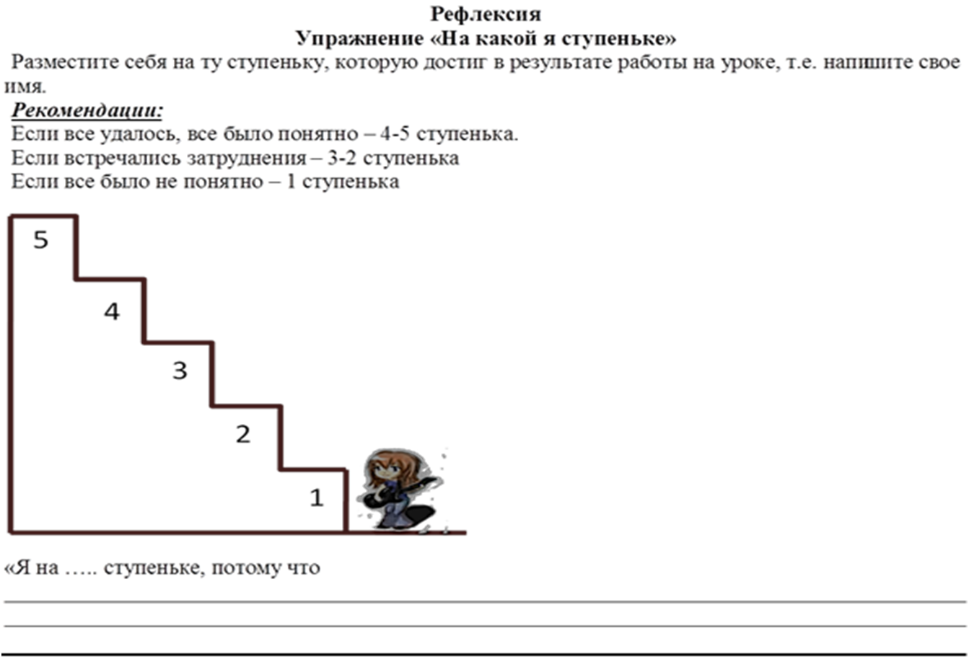
Thank you very much. See you later. Bye

